**Check If It Is a Straight Line**

You are given an array coordinates, coordinates[i] = [x, y], where [x, y] represents the coordinate of a point. Check if these points make a straight line in the XY plane.

**Example 1:**

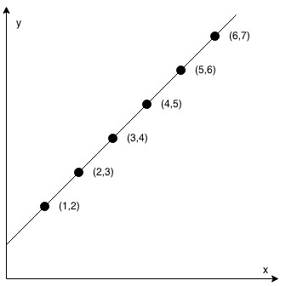

**Input:** coordinates = [[1,2],[2,3],[3,4],[4,5],[5,6],[6,7]]

**Output:** true

**Example 2:**

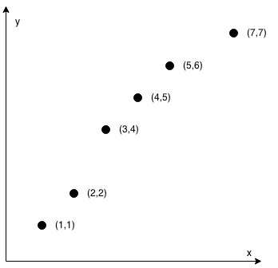

**Input:** coordinates = [[1,1],[2,2],[3,4],[4,5],[5,6],[7,7]]

**Output:** false

**Constraints:**

* 2 <= coordinates.length <= 1000
* coordinates[i].length == 2
* -10^4 <= coordinates[i][0], coordinates[i][1] <= 10^4
* coordinates contains no duplicate point.